Optimization Study of Energy Absorbing Cargo Restraint Systems

W. Kong¹, E. C. Smith¹, M. A. Yukish², G. M. Stump² & C. E. Bakis¹

¹The Pennsylvania State University, University Park, PA
²The Applied Research Laboratory, State College, PA

Abstract

In the event of a helicopter crash with high G loadings, cargo can break free from its restraints and jeopardize crew safety. The use of energy absorbing devices (e.g., load limiters) in restraint systems can arrest the motion of cargo, reduce the load transmitted to mounting points and ensure crew safety. However, designing energy absorbing restraint systems is complicated by the changing geometry of the restraint system as it absorbs energy during a crash, and by the nonlinear relationship between cargo displacement, rate, and applied restraint forces. To help design restraint systems, a simulation-based method and tools for selecting and configuring optimal energy absorbing cargo restraint systems was conceived. A cargo dynamics simulation was developed to analyze the interaction between cargo, restraint system, and the cabin floor. The simulation is coupled to a multi-dimensional data exploration and visualization software to exercise the simulation over the design space and visualize results. An example design study is presented, where the objective functions were to minimize the number of restraints, total mass of restraints and cargo displacement. With high strength mounting points, the optimal energy absorbing cargo restraint system had a reduction of 32% in number of restraints and 25% in total mass when compared to chains. The resulting cargo displacement for the optimal restraint system was 45 cm. To further reduce transmitted loads to accommodate current rotorcraft requires an increase in the number of restraints. Lower strength chains that are currently used, however, were incapable of satisfying the crashworthiness requirements and unable to provide adequate safety.

Keywords: cargo restraints, crashworthiness, energy absorbers, tear webbing, textile-based devices, load limiter, optimization, cargo dynamics, tie-downs

Introduction
In the event of a helicopter crash, the dangers of out-of-control cargo are severe and can lead to fatalities in what could otherwise be considered a survivable crash. The Aircraft Crash Design Guide (ACSDG), used by the U.S. Army for crashworthy restraint requirements [1], specifies a 16 G peak forward impact requirement. The requirements listed in the current US Army field manual for internal load operations are deficient by ACSDG standards as it calls for a static load factor of only 4 G’s [2]. Increasing payload requirements for future heavy-lift rotorcraft, such as that under investigation in the Joint Heavy Lift program [3], will increase the forces required to arrest cargo. The use of energy absorbing devices can improve restraint systems to satisfy ACSDG requirements as well as reduce transmitted loads, number of restraints, and total restraint weight.
The downfall of current restraint technologies used in military rotorcraft (e.g., steel chains, nylon straps) is the high peak forces transmitted to the mounting points. Load limiters can reduce these forces and dissipate energy, but device stroke is required. In the 1970s and 1980s, research was conducted on load limiting devices such as inversion tubes, rolling torus, and wire benders for use on military rotorcraft [1], [4]. Wire benders were eventually used on cargo rotorcraft, but were abandoned by cargo handling crews citing issues with usability. More recent efforts by Wess et al [5] - [7] , include investigations into textile-based load limiting devices (e.g., stitch ripping devices, tear webbing). Compared to wire-benders, textile-based load limiters were an improvement in terms of specific energy absorption and user-friendliness. The analyses presented in this paper incorporate a tear webbing device in cargo restraint systems.
Incorporating load limiters can improve crashworthiness of cargo restraint systems, but also complicate their design due to the changing geometry of the restraint system and nonlinear relationship between cargo displacement, rate, and applied restraint forces. A cargo dynamics simulation has been developed for system-level analysis of restraint systems in a crash environment. The simulation is coupled to the Applied Research Laboratory Trade Space Visualizer (ATSV) – a multi-dimensional data exploration and visualization software – to exercise the simulation over the design space and visualize the results. An example design study is presented where the objective functions were to minimize the number of restraints, mass of the restraint system, and cargo displacement. The optimal energy absorbing restraint system was also compared to a steel chains.

Energy Absorbing Restraints
Cargo restraints are just one component of the overall system as shown in Figure 1. Energy absorbing restraints consist of two components: load limiter and lanyard. Load limiters are not long enough to cover the distance between mounting so lanyards are used. Examples of lanyards that can be used include
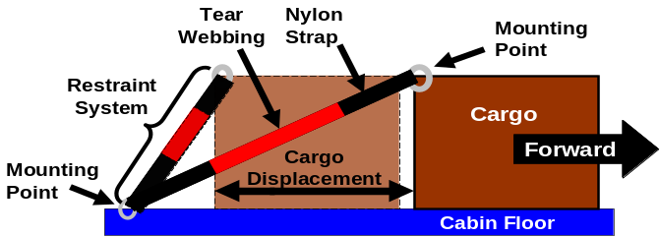
Figure 1: The vehicle-level system before and after a forward crash event.

fabric straps and steel chain. Compared to steel chains, fabric straps are lightweight, relatively inexpensive and have the added ability to wrap around cargo to provide restraint. In the event of a crash, load limiters will limit the load transmitted to the mounting points and dissipate the kinetic energy of the cargo. The load limiter will also stroke during this process, resulting in cargo displacement. For the purposes of the analysis conducted in this paper, the cargo restraint system consists of a nylon strap and a tear webbing device.
Tear webbing is made of two pieces of polyester webbing sewn together with polyester binder yarns. The energy absorbing mechanism is the rupture of the yarns as the pieces of webbing are pulled apart. The force required to break the binder yarn – the “activation force” – should be as close as possible to the load capacity of the mounting points according to the ACSDG [1]. The mass of tear webbing is linearly proportional to its activation force and stroke. A tear webbing device with an activation force of 44.5 kN and a maximum stroke of 30 cm, has a mass of 0.73 kg. To have double the activation force, or stroke, would result in a device with double the mass.
The force-displacement response of idealized tear webbing is shown in Figure 2. There are three phases: initial loading, load limiting and post-deployment. As the tear webbing is initially loaded in tension, the response is identical to polyester webbing until the activation force is reached. At this point, the load is limited to the activation force until all binding yarns are ruptured and the device has reached maximum stroke. The final post-deployment response is that of an extended polyester webbing – with reduced stiffness – until failure.

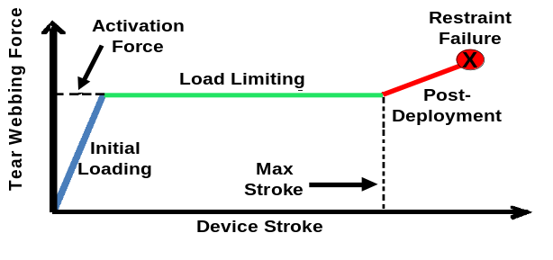
Figure 2: Plot of the force-displacement response of idealized tear webbing.

Cargo Dynamics Simulation and Optimization Method
The complicated dynamics of the problem and nonlinear behaviour of the restraints excludes closed form analysis. Therefore, a cargo dynamics simulation was developed to conduct analyses, coupled with design tools, to explore the possible restraint configurations and determine the best design. A flowchart of the optimization method is shown in Figure 3.

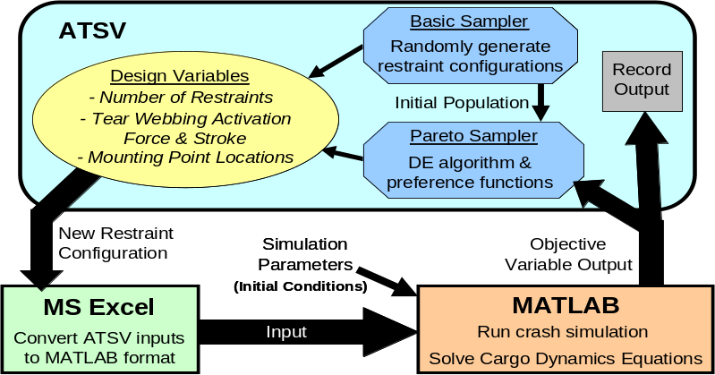
Figure 3: Flowchart of the optimization method.

Cargo Dynamics Analysis
The cargo dynamics simulation analyzes the interaction between the components of the vehicle-level system: cargo container, restraint system, and the cabin floor. The model was developed in MATLAB to solve a system of state equations for rigid bodies with six degrees of freedom. The MATLAB solver used is ode45.
The dynamics of the cargo container are affected only by the applied forces of the restraint system,

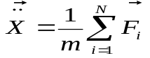. | (1)

where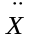is the acceleration of the cargo center of gravity, F_{i} is the restraint force on the cargo from the i^{th} restraint, N is the number of restraints, and m is cargo mass. The cargo and cabin floor are rigid bodies subject to a purely longitudinal impact. The forces exerted by the energy absorbing restraints are a function of the distance between cargo and cabin floor mounting points (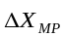), total restraint stiffness (K_{Total}), activation force (f_{ACT}) and max stroke (S_{max}):

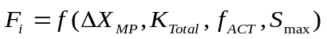, 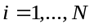. | (2)
The restraint system consists of a nylon strap and tear webbing device connected in series. Therefore, the expression for the total restraint stiffness (K_{Total}) during initial loading and post-deployment phases can be written as

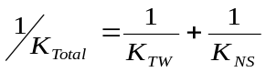, | (3)

where K_{TW} is the tear webbing stiffness and K_{NS} is the nylon strap stiffness. Nylon strap stiffness is proportional to its effective length. At the activation force, strap elongation is 7.5% of the effective length. A tear webbing device rated for 44.5 kN has a stiffness value of 5310 kN/m prior to activation. The value of K_{TW} is reduced in the post-deployment phase as shown in Figure 2.
To simplify the analysis, cabin floor dynamics are not affected by the cargo or restraint forces, but only by the crash pulse imparted to the cabin floor per the simulation parameters discussed later. Cargo-cabin floor friction is not taken into account as studies by Romero et al [8] have shown that it is not a reliable factor in arresting cargo. The initial conditions for the state equations are

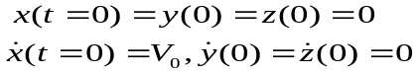, | (4)

where x, y, and z represent the translation of the cargo CG and V₀ is the impact velocity. The x, y, and z axes represent the longitudinal, lateral and vertical directions, respectively.

ATSV
The Applied Research Laboratory Trade Space Visualizer (ATSV) can sample and explore multi-dimensional trade spaces with an array of visual steering commands including random sampling, attractor-based sampling and Pareto sampling. The Exploration Engine feature acts as the mediator between ATSV and the simulation model via Excel to sample the input space and generate new design alternatives [9]. The random sampler performs Monte Carlo simulations on the inputs. The Pareto sampler uses Differential Evolution to guide the sampling process [10]. Pareto sampling generates solutions along a Pareto front that is defined by a user-specified direction of preference for each objective function. ATSV’s visualization and data analysis tools are subsequently used to determine the optimal design (i.e. optimal restraint system).
Initially, the random sampler is used to explore the design space and identify trends. ATSV generates restraint systems by defining pairs of mounting points for attachment, total number of restraints and tear webbing device parameters (i.e. activation force, stroke). The input variables are sent to MS Excel to be converted into a MATLAB compatible format. The cargo dynamics simulation evaluates the given restraint system in a crash event defined by the ACSDG. The results from the simulation serve as the objective function outputs and are sent back to Excel and ATSV to be recorded. An initial population for the Pareto sampler can be chosen from the randomly generated restraint configurations.

Simulation Parameters
To simplify the analysis, the analysis focuses on purely longitudinal impacts. The ACSDG crash simulation criteria consist of a dynamic pulse in the shape of an equilateral triangle as shown in Figure 4. The pulse duration is 0.16 seconds with a 16 G peak. A crash event begins with both the cargo and cabin floor moving at the impact velocity (V₀) of 13 m/s [1]. At some point in time, the cabin floor is subject to a crash pulse and decelerates. The motion of the cargo can be arrested only by restraint forces.
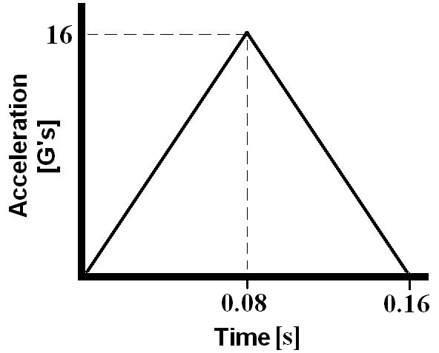
Figure 4: Plot of the triangular crash pulse for model simulations

Objective Functions
The objective functions of the optimization study are to minimize the number of restraints, total mass and cargo displacement. Several unique restraint configurations can be possible with a given number of restraints and each with a different mass. Cargo displacement constraints are dependent on the situation (i.e. cargo/cabin dimensions, troop seat arrangements). Cargo movement can be expected when using nylon straps or chains, but cargo displacement should be minimized to avoid blocking exits and injury to passengers.

Design Space
The design variables include number of restraints, tear webbing parameters and tie-down configuration. The tie-down configuration refers to the manner in which restraints are attached to mounting points – defining the effective strap lengths and tie-down angles. For each restraint, mounting points on the cargo container and cabin floor are chosen for attachment. There can be no more than one restraint attached to a single mounting point. Tie-down configurations are symmetric about the longitudinal axis to prevent rotation in a forward impact. The load capacity of the mounting points matches the activation force of the restraints. Restraints are attached to mounting points in a straight line that does not cut through the cargo container.
Lateral [m] | 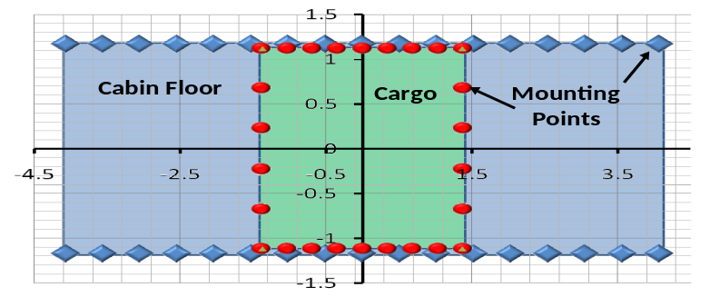  Longitudinal [m]
Figure 5: Top view of mounting points on cabin floor (blue) and cargo (red).

Sample Results: Optimization Studies
Optimization studies were conducted for energy absorbing restraints and chains to provide a baseline for comparison.

Model Configuration
A diagram of the model configuration is shown in Figure 5. The cargo component of the system is a single rigid container that is 2.74 m long × 2.24 m wide × 1.22 m high. The container has a mass of 4536 kg. There are 26 mounting points located on the top edges of the container.
The cabin floor design is loosely based on existing cargo rotorcraft. The dimensions are 8.1 m long × 2.3 m wide with 17 evenly spaced mounting points on each side of the floor. Current rotorcraft can have mounting points rated up to 88.9 kN, but the ACSDG recommends greater load capacity even with the use of load limiters [1]. The cabin floor used in this analysis will use mounting points rated up to 111 kN – typical to fixed wing cargo aircraft.
The nylon strap is similar to the CGU-1/B restraint used on aircraft today. CGU-1/B straps are rated to 22.2 kN, with a mass of 1.7 kg, and a length of 6.1 m [11]. Studies on nylon show an average elongation of 7.5% at 22.2 kN [1]. The straps used in the analysis linearly scale the CGU-1/B to be used for restraints with tear webbing. For example, to accommodate an activation force of 111 kN, the equivalent of five CGU-1/B straps stacked together in parallel. The strap mass is 8.5 kg. The strap elongation is 7.5% of the effective length at the activation force.
Energy absorbing restraint systems are compared to chain restraints as they are commonly used by cargo handlers today. There are two types of chain restraints: Type I and II. Type I restraints are used on 44.5 kN mounting points that are typically used on rotorcraft. Type II restraints are for mounting points up to 111 kN which are found on fixed wing cargo aircraft. The mass of Type I and II restraints are 3.6 kg and 10.9 kg respectively [12]. Both types of chain restraints come in a standard length of 2.7 m.

Optimization Study #1: Chains
The process for determining the optimal configuration for chains is simpler than for energy absorbing restraints. The geometry of the problem is fixed as the restraints are assumed not to elongate and static load factors are used. The restraint configuration for chain restraints can be calculated using the following formula [2]:

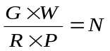, | (5)

where G is the peak crash load factor, W is the cargo weight, R is the chain strength, P is percent of effective restraint, and N is the number of restraints required. As an example, all chains are tied down with an angles of 30º from the longitudinal axis and 30º from the floor (referred to as tie down angle of 30º/30º). The percent of effective restraint in the longitudinal direction is 75%. Substituting the numbers obtained from Simulation Parameters and Model Configuration sections, we can calculate the number of restraints required to arrest cargo in a longitudinal impact if all chains are tied down at 30º/30º:

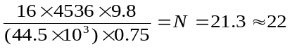, | (6)

The value for N is rounded to the nearest even integer for a symmetric configuration. The formula shows that N is inversely proportional to the percent of effective restraint. Therefore, the optimal chain restraint configuration for longitudinal impacts requires all restraints to be as closely aligned with the longitudinal axis (0º/0º) as possible.
An optimal configuration for Type I chains does not exist. Due to the short length of the chains and mounting point locations, only 20 restraints can be used. However, 20 Type I chains could not provide sufficient restraint to satisfy the crash requirements. The optimal configuration for Type II restraints is shown in Figure 6. There are eight Type II restraints with a total mass of 87 kg.

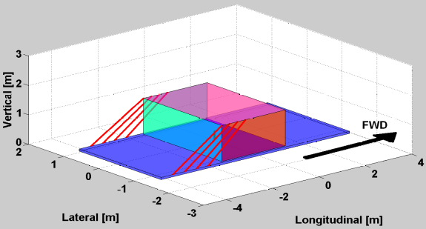
Figure 6: Optimal restraint configuration for steel chains.

Optimization Study #2: Energy Absorbing Restraint System
The second optimization study focuses on restraints with nylon strap and tear webbing. A maximum cargo displacement constraint of 50 cm was applied to the results. A plot of the resulting feasible and Pareto designs is shown in Figure 7. The objective preferences defining the Pareto front are provided in Section 3.4.
Designs A and B are sample Pareto optimal restraint configurations. Details on these designs are shown in Table 1. The configurations for Designs A and B can be found in Figure 8 and Figure 9, respectively. Compared to the optimal Type II chain restraints, Design A provides a 32% reduction in total mass and a 25% reduction in the number of restraints required. Design B is another Pareto optimal design, where minimizing cargo displacement is preferable. However, decreasing cargo displacement requires an increase in mass and the number of restraints. Design B can reduce cargo displacement to 22cm, but with an increase of 21 % in total mass and 50% more restraints compared to Type II restraints. Designs A and B are Pareto optimal designs, but the most preferred design would be a function of the relative weighting of the objectives. If minimizing total mass is more important than minimizing cargo displacement, Design A would be the better choice. However, all Pareto optimal designs feature an activation force of 111 kN. Therefore, increasing activation force can further minimize our objectives including cargo displacement.

Table 1: Sample results from the second optimization study.

Design | No. of Restraints | Total Mass | Activation Force | Stroke | Cargo Displacement
A | 6 | 59 kg | 111 kN | 21 cm | 45 cm
B | 12 | 106 kg | 111 kN | 6 cm | 22 cm
C | 16 | 63 kg | 44.5 kN | 21 cm | 44 cm

One of the key advantages of load limiters is the ability to reduce loads transmitted to the mounting points and airframe. Thus allowing designers of future rotorcraft to save on structural weight and achieve crashworthiness. Design C is the resulting optimal configuration from fixing the activation force to 44.5 kN to accommodate current cargo rotorcraft. The restraint configuration for Design C is shown in Figure 10. The maximum cargo displacement constraint is kept to 50 cm. Design C shows that decreasing activation force requires a significant increase in the number of restraints. However, the number of restraints required could be significantly decreased with more allowable cargo displacement. A direct comparison to chains cannot be made due to the fact that no feasible configurations exist for Type I restraints. Therefore, Type I restraints are incapable of satisfying the ACSDG requirements and are unable to provide adequate safety. Compared to Type II chains, Design C has 28% less mass, but with twice the number of restraints. The key advantage Design C possesses over Type II chains is that it reduces the load transmitted to the mounting points by 60% – making it feasible for use on current cargo rotorcraft.
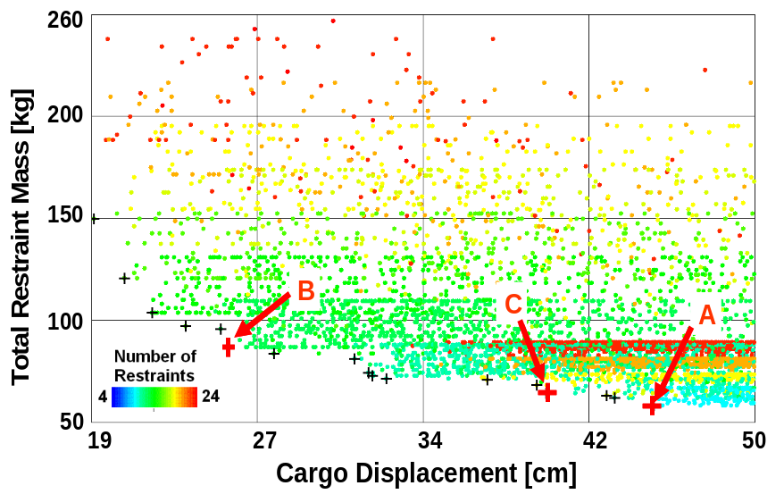
Figure 7: Feasible restraint system designs plotted as cargo displacement vs. restraint system mass. Pareto optimal designs are marked by (┼).

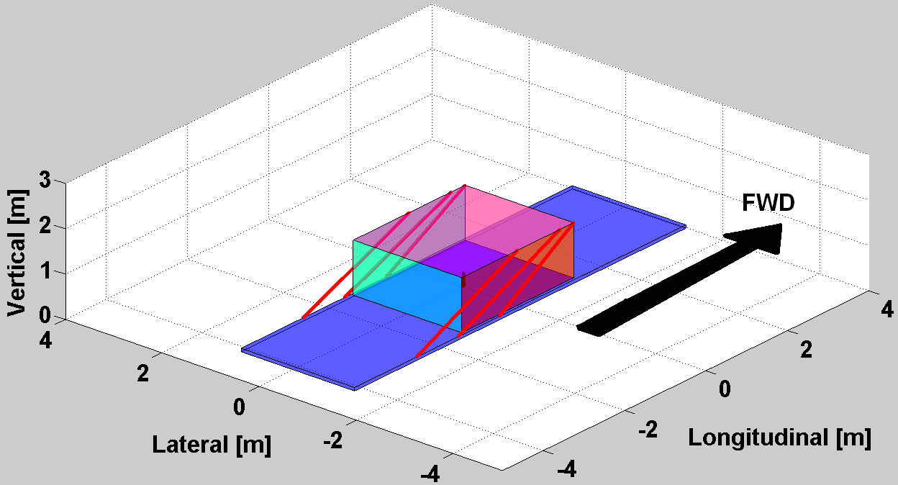
Figure 8: Restraint configuration for Design A.

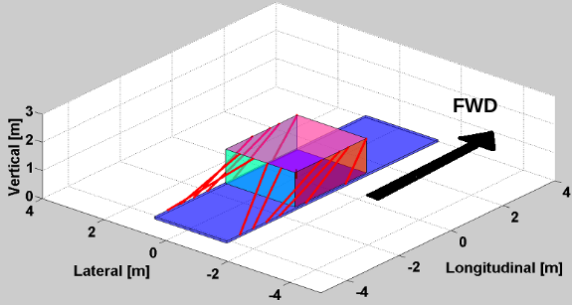
Figure 9: Restraint configuration for Design B.

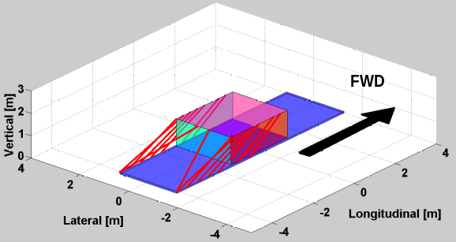
Figure 10: Optimal restraint configuration for Design C.

Conclusions
A method and tools have been developed to select and configure energy absorbing cargo restraint systems that are optimized for crew safety. The results of the optimization study show that energy absorbing cargo restraint systems are an improvement over chains in terms of the number of restraints and total mass – with some allowable cargo displacement. Several Pareto optimal designs exist and the final choice depends on the weighting of preferences. With a high activation force, energy absorbing restraints can reduce total mass by 33% and have 25% fewer restraints compared to high strength chains; but with a cargo displacement of 45 cm. If less displacement is preferable, the restraint configuration that requires only 22 cm of cargo displacement has a 22% increase in total mass and 25% more restraints. A reduction in transmitted loads for use in current rotorcraft is also possible, but more restraints are needed. When compared to high strength Type II chains, the optimal configuration with lower activation force has 28% less mass and double the number of restraints. The resulting cargo displacement was 45 cm. Comparisons to Type I chains were not possible due to the lack of feasible configurations.
The number of restraints, total mass, and activation force can be reduced by increasing allowable cargo displacement. Increasing tear webbing stroke can minimize objectives, but only with an increase in displacement constraints. To avoid excess weight, it is recommended that tear webbing stroke is the designed to be the minimum required to arrest the cargo. An alternative avenue for improvement is increasing activation force (i.e. mounting point load capacity). All Pareto optimal configurations featured the highest activation force possible. Therefore, higher activation forces can further minimize cargo displacement, number of restraints and total mass. A stiffer fabric strap can also reduce cargo displacement and increase efficiency: displacement should be a result of tear webbing stroke as it dissipates energy as opposed to elastic strap elongation.
It is recommended that future heavy lift rotorcraft are designed with stronger mounting points and more cabin space. For existing rotorcraft, currently used chains are unable to provide adequate safety and should be replaced by energy absorbing restraints. Furthermore, any cargo restraint system suggested as feasible by the proposed optimization method requires a final step of review by the user to assess its practicality and usability.

Acknowledgements
This research was partially funded by the Office of Naval Research under the Award No. N00014-08-C-0420. Any opinions, findings and conclusions or recommendations expressed in this publication are those of the authors and do not necessarily reflect the views of the Office of Naval Research. Additional funding was provided through the NDSEG Fellowship with sponsorship from Army Research Office. The authors also thank Doug Mousseau of Navair for his recommendations and insight.

References
- Simula Inc., Aircraft Crash Survival Design Guide: Volume III. USAAVSCOM TR 89-D-22C, 1989.
- Department of the Army, Field Manual: Army Helicopter Internal Load Operations. FM 55-450-2, Washington, D.C., 1992.
- Tenney, B. S., Joint Heavy Lift -- Full Steam Ahead. Vertiflite, 54 (2) , pp. 18-20, 2008.
- Shefrin, J., Russe, A. & Reichardt, W. T., Integral Helicopter Restraint System. Boeing Vertol: Philadelphia, PA, 1969.
- Wess, D. B., Aircraft restraint mechanism. Technical Memorandum 04-094, Applied Research Laboratory: State College, PA, 2004.
- Hagon, M. J., Bakis, C.E., Yukish, M. A. & Smith, E. C., A new look at lightweight energy absorbing devices for heavy cargo restraints. Proc. of the American Helicopter Society 63rd Annual Forum, AHS International: Alexandria, VA, pp. 1176 - 1186, 2007
- Hagon, M. J., Kong, W., Bakis, C. E., Yukish, M. A. & Smith, E. C., Energy-absorbing textile devices for heavy cargo restraints. Proc. of the American Helicopter Society 64th Annual Forum, AHS International: Alexandria, VA, pp.737 – 755, 2008
- Romero, J.A., Restrained cargo dynamics in road transportation. Heavy Vehicle Systems, 11(2), pp 116, 2004.
- Stump, G., Lego, S., Yukish, M., Simpson, T. W. & Donndelinger, J. A., Visual steering commands for trade space exploration: user-guided sampling with example. Journal of Computing and Information Science in Engineering, 9 (4), pp. 044501-1 – 044501-10, 2009.
- Price, K., Storn, R. & Lampinen, J. Differential evolution – A practical approach to global optimization. Springer-Verlag: Berlin, 2005.
- Department of Defense, Detail specification: tie down, cargo, aircraft, CGU-1/B. MIL-PRF-27260C, 1998.
- Department of Defense, Detail specification: chain assemblies, single leg, aircraft cargo tie-down. MIL-DTF-6458F, 2008.

